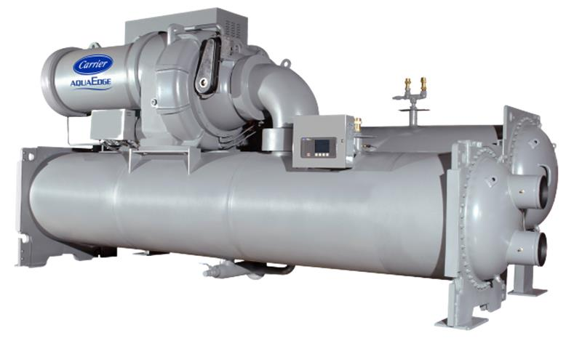

Chiller background
Chiller details | Information
Chiller Number | $ChillerSN
Location | $LocationName
Customer Name | $CustomerName
City | $LocationCity
Year of Manufacturing (Age) | $Year_Age
Model Number | $ModelNum
Chiller Run Hours | $runhrs
Report Duration | $StartDate to $EndDate
Chiller Capacity (RT) | $DesignRT
Rated Chilled Power (kW) | $DesignChillerPower
Design Leaving Chilled Water Temperature ($T_Unit) | $Design_LCW
Design Entering Condenser Water Temperature ($T_Unit) | $Design_ECDW
Report Release Date | $Today_date
**** Confidential - For Recipient's Use Only. Unauthorized Sharing is Prohibited.
Summary
 | As part of Carrier's connected service program, our command center experts continuously monitor the performance and health of the chiller and its major components.
 | The chiller with serial number $ChillerSN underwent a chiller retrofit analytics program considering its age and run hours exceeding 20 years or 70,000, respectively. Further analysis was conducted using real-time data from $StartDate to $EndDate.
$GeneralThe chiller's design full load $performance_str is $Design_Efficiency $performance_unit at design conditions of $Design_LCW$T_Unitfor chilled water and $Design_ECDW$T_Unit for condenser water. $General$case1When evaluated under these same design conditions, the computed chiller $performance_str is $same_condition_effi $performance_unit. This comparison uses the design temperature parameters for a direct assessment of performance during the analysis period.$case1$case2By adjusting the actual operating conditions to match these design temperatures, the adjusted chiller $performance_str is $same_condition_effi $performance_unit*. This adjustment aligns the actual operating conditions with the design specifications, providing a clear basis for comparison for data points that are greater than 80%** of RLA during the analysis period. $case2$case3 No Enough Data points to compute and compare with Design Data. $case3
* Adjusted $performance_str by $deviation_per% for 1 deviation of $T_unit from design chilled water and condenser water temperature.
** $data_count data points used for computation
 | $positive_deter1. Chiller $performance_str deteriorate by $DeterEffi% compared to design $performance_str.$positive_deter  $negative_deter1. Chiller efficiency improved by $DeterEffi% compared to design efficiency due to good maintenance and computational/ sensor error.$negative_deter
 | 2. Chiller device has total of $total_alarms alarms during analysis period.
 | These are initial analytic and findings of a chiller performance from telemetry data within a specified period. Further investigation and energy assessment on chiller plant level are recommended to understand existing chiller plant baseline performance. Carrier offers in-house engineering tools to assist our customers in developing new solution with optimized configuration and operation.

Chiller Performance Analysis
$effi_PLC_ECDW
Comments
- The chiller $performance_str $performance_unit is steadily $trend compared to the previous year, indicating an increase in energy consumption per unit of cooling output.
- This trend indicates a potential decline in efficiency, emphasizing the need for further investigation to address and rectify underlying issues.
- The chiller $performance_str $performance_unit is similar compared to the previous year.
$Chiller efficiency vs %RLA vs Runhrs
Comments
- This plot illustrates various part-load efficiencies based on specific criteria:
  - The chiller operates at full load for more than 80% of the time: $full_load_80
  - The chiller frequently operates at less than 60% of its RLA for most of the time (more than 80% of the time): $low_load_80
  - Chiller $performance_str at ($Tonrange_per%) RT is at $MostRunhrsPerformance $performance_unit compared to >90% RT is at $90TonPerformance $performance_unit.
  - The chiller is installed with VFD: $is_installed_VFD.
$Chiller efficiency vs Cooling load vs Runhrs
Comments
- This plot illustrates various part-load efficiencies at different Cooling Loads:
  - Most of the time ($MostRunhrsOFTon%) chiller operates from $Ton_range RT.
Chiller Alarm Analysis
$alarm_count
Comments
- The chiller device has total of $total_alarms alarms during this analysis timeframe.
- There have been $exceed_15 instances of chiller device alarms exceeding 15 in the last 2 months.
Chiller Water Temperature Analysis
$LCW_SP
Comments
- The leaving chilled water temperature meets $setpoint_meet%, the set point.
$Entering_Condenser_Water
Comments
- The average entering condenser water temperature falls within the range of $min_ECDW$T_Unit to $max_ECDW$T_Unit.
$2022infoChiller Data 2022 (Standard Average)
Year 2022 | Jan | Feb | Mar | Apr | May | Jun | Jul | Aug | Sep | Oct | Nov | Dec
Leaving Chilled water temperature, °F
Chiller power consumption, kW
Chiller efficiency, kW/RT
Cooling load, RT
Entering Condenser water temperature, °F
Chiller energy consumption, kWh
“-”: No Telemetry

$Temperature_Ton_2022

$Effi_EnergyConsumption_2022
Placeholder
$Ton_power_2022

$2022info$2023info Chiller Data 2023 (Standard Average)
Year 2023 | Jan | Feb | Mar | Apr | May | Jun | Jul | Aug | Sep | Oct | Nov | Dec
Leaving Chilled water temperature, °F
Chiller power consumption, kW
Chiller efficiency, kW/RT
Cooling load, RT
Entering Condenser water temperature °F
Chiller energy consumption, kWh
“-”: No Telemetry
$Temperature_Ton_2023

$Effi_EnergyConsumption_2023

$Ton_power_2023

$2023info$2024info Chiller Data 2024 (Standard Average)
Year 2024 | Jan | Feb | Mar | Apr | May | Jun | Jul | Aug | Sep | Oct | Nov | Dec
Leaving Chilled water temperature, °F
Chiller power consumption, kW
Chiller efficiency, kW/RT
Cooling load, RT
Entering Condenser water temperature °F
Chiller energy consumption, kWh
“-”: No Telemetry
$Temperature_Ton_2024

$Effi_EnergyConsumption_2024
Placeholder
$Ton_power_2024
$2024info

